**PIZZA Sales SQL Queries**

**A.KPI’s**

**1.Total Revenue:**SELECT round(SUM(total_price),2) AS Total_Revenue from pizza_sales

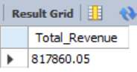

**2.Average Order Value:**

SELECT round(SUM(total_price) / COUNT(DISTINCT order_id),2) as Avg_Order_Value from pizza_sales

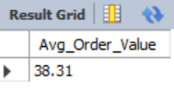

**3.Total Pizza Sold:**

SELECT SUM(quantity) as Total_Pizza_Sold from pizza_sales  
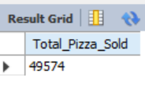

**4.Total Orders:**

SELECT COUNT(DISTINCT order_id) AS Total_Orders from pizza_sales

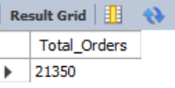

**5.Avg Pizzas Per Order:**

SELECT round(SUM(quantity) /

COUNT(DISTINCT order_id),2) As Avg_Pizzas_per_Order from pizza_sales

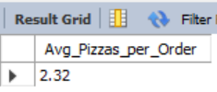

**B. Charts Requirment**

**1. Total Trend for total orders:**

SELECT DAYNAME(order_date) as order_day, COUNT(DISTINCT order_id) as Total_Orders

from pizza_sales

GROUP BY 1;

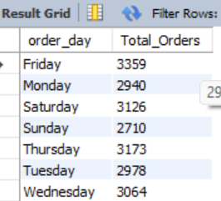

**2.Monthly Trends for Orders:**

SELECT DATENAME(order_date) AS Month_Name, COUNT(DISTINCT order_id) AS Total_Orders

from pizza_sales

GROUP By 1

ORDER BY Total_Orders DESC

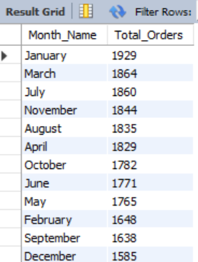

**3. Percentage of Sales by Pizza Category:**

SELECT pizza_category, round(sum(total_price),2) as Total_Sales, round(sum(total_price)/ (SELECT sum(total_price) from pizza_sales) * 100),2) AS PCT_Total_Sales

from pizza_sales

GROUP BY pizza_category

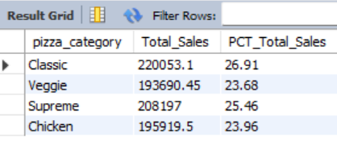

**4.Percentage of Sales by Pizza Size:**

SELECT pizza_size, round(sum(total_price),2) as Total_Sales, round(sum(total_price)/

(SELECT sum(total_price) from pizza_sales) * 100,2)=]]9 AS PS_Total_sales

from pizza_sales

GROUP BY pizza_size

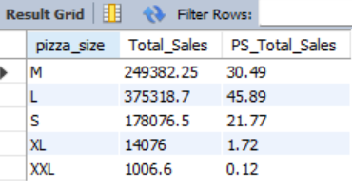

**5. Total Pizzas Sold by Category:**

SELECT pizza_category, SUM(quantity) as Total_Quantity_Sold

FROM pizza_sales

GROUP BY pizza_category

ORDER BY Total_Quantity_Sold DESC

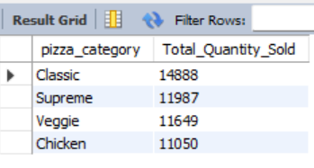

**6. Top 5 Pizzas by Revenue:**

SELECT pizza_name, sum(total_price) as Total_Revenue from pizza_sales

GROUP BY pizza_name

Order By Total_Revenue DESC limit 5;

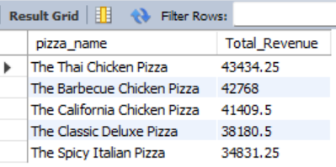

**7. Bottom 5 Pizzas by Revenue:**

SELECT pizza_name, round(SUM(total_price),2) AS Total_Revenue

FROM pizza_sales

GROUP BY pizza_name

ORDER BY Total_Revenue limit 5;

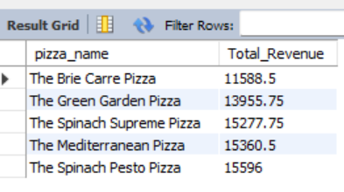

**9. Top 5 Pizzas by Quantity**

SELECT pizza_name, SUM(quantity) AS Total_Pizza_Sold

FROM pizza_sales

GROUP BY pizza_name

ORDER BY Total_Pizza_Sold DESC limit 5;

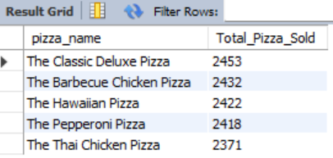

**10. Bottom 5 Pizzas by Quantity**

SELECT pizza_name, SUM(quantity) AS Total_Pizza_Sold

FROM pizza_sales

GROUP BY pizza_name

ORDER BY Total_Pizza_Sold limit 5;

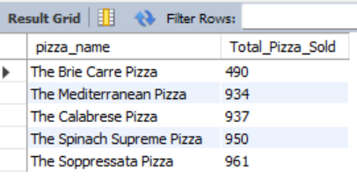

**11. Top 5 Pizzas by Total Orders**

SELECT pizza_name, COUNT(DISTINCT order_id) AS Total_Orders

FROM pizza_sales

GROUP BY pizza_name

ORDER BY Total_Orders DESC limit 5;

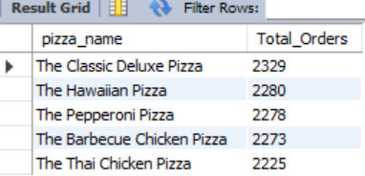

**12. Bottom 5 Pizzas by Total Orders**

SELECT pizza_name, COUNT(DISTINCT order_id) AS Total_Orders

FROM pizza_sales

GROUP BY pizza_name

ORDER BY Total_Orders limit 5

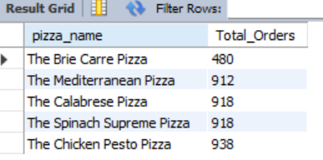

***NOTE***

If you want to apply the pizza_category or pizza_size filters to the above queries you can use WHERE clause. Follow some of below examples

SELECT pizza_name, COUNT(DISTINCT order_id) AS Total_Orders

FROM pizza_sales

WHERE pizza_category = 'Classic'

GROUP BY pizza_name

ORDER BY Total_Orders limit 5